

***NAME: KASHIF MAJID***

***PRN: 19070122084***

***BATCH: CS-B1***

***ASSIGNMENT 9***

***Topic: STRINGS***

***Theory:***

In **C programming**, a **string** is a sequence of characters terminated with a null character \0 . ... char **c**[] = "**c string**"; When the compiler encounters a sequence of characters enclosed in the double quotation marks, it appends a null character \0 at the end by default.

# *OBJECTIVE:* Write a C program to accept a string from console and to display the following on console (without using built-in functions): (a) Length of the string

**Algorithm:**

**1) START**

**2) SAVE THE STRING IN S**

**3) INITIALISE C=0,RUN A LOOP TILL**

**S[C]!=’\0’**

**4) DISPLAY THE VALUE OF C**

**5) END**

# *Flowchart:*

# 

# *Source Code:*

#include <stdio.h>

#include <stdlib.h>

/* run this program using the console pauser or add your own getch, system("pause") or input loop */

int main() {

char a[1000];

int i=0;

printf("enter a string:");

scanf("%s",a);

while(a[i] !='\0')

{

i++;

}

printf("lenght of the string is:%d",i);

return 0;

}

# *OUTPUT:*

# 

# b) Total number of characters in the string

**Algorithm:**

**1) START**

**2) SAVE THE STRING IN S**

**3) INITIALISE C=0,RUN A LOOP TILL**

**S[C]!=’\0’**

**4) DISPLAY THE VALUE OF C**

**5) END**

# *Flowchart:*

# 

# *SOURCE CODE:*

#include <stdio.h>

#include <stdlib.h>

/* run this program using the console pauser or add your own getch, system("pause") or input loop */

int main() {

char a[1000];

int i=0;

printf("enter a string:");

scanf("%s",a);

while(a[i] !='\0')

{

i++;

}

printf("lenght of the string is:%d",i);

return 0;

}

# *OUTPUT:*

# 

# (c) Total number of vowels in the string

**Algorithm:**

**1) START**

**2) SAVE THE STRING IN S**

**3) INITIALISE C=0,RUN A LOOP TILL**

**S[C]!=’\0’**

**4) FOR EACH C RUN A LOOP TO CHECK IF**

**THE GIVEN CHARACTER IS IN VOW, IF**

**YES THEN INCREMENT V BY 1**

**5) DISPLAY V**

**6) END**

***Flowchart:***

***Source Code:***

#include <stdio.h>

#include <stdlib.h>

/* run this program using the console pauser or add your own getch, system("pause") or input loop */

void main() {

char a[1000],b='aeiou';

int i=0,count=0;

printf("enter a string:");

scanf("%s",a);

while(a[i] !='\0')

{

if(a[i]=='i'|| a[i]=='a'|| a[i]=='e'|| a[i]=='o'|| a[i]=='u' )

{

count++;

}

i++;

}

printf("total vowels in the string:%d",count);

}

***OUTPUT:***

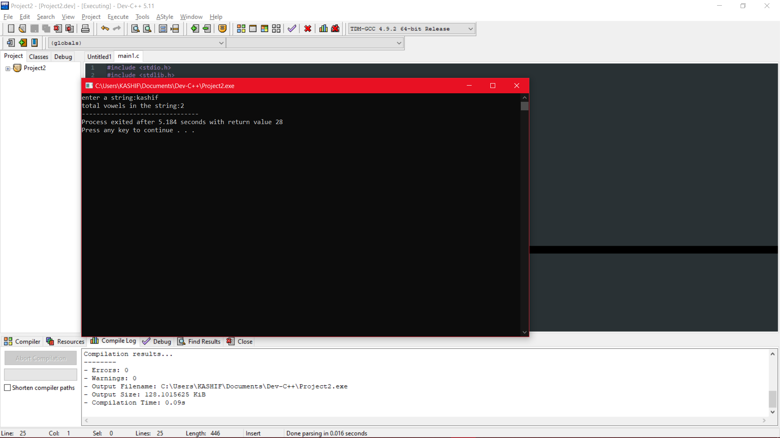

# (d) Copy one string into the other.

**Algorithm:**

**1) START**

**2) SAVE THE STRING IN S**

**3) INITIALISE C=0,RUN A LOOP TILL**

**S[C]!=’\0’**

**4) FOR EACH C STORE THE VALUE IN**

**ANOTHER STRING S2.**

**5) DISPLAY S2**

**6) END**

***Flowchart:***

***Source Code:***

#include <stdio.h>

/* run this program using the console pauser or add your own getch, system("pause") or input loop */

int main() {

char a[1000],b[1000];

int i;

printf("enter a string:");

scanf("%s",a);

for(i=0;a[i]!='\0';i++)

{

b[i]=a[i];

}

b[i]='\0';

printf("string typed:%s",a);

printf("\ncopied string:%s",b);

return 0;

}

***Output:***

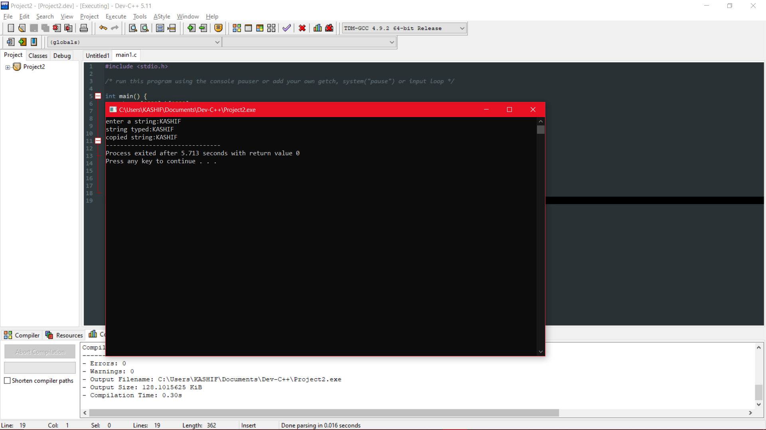

# (e) Reverse of the string

**Algorithm:**

**1) START**

**2) SAVE THE STRING IN S**

**3) INITIALISE I=0,C=LENGTH,RUN A LOOP**

**TILL S[C]!=’\0’**

**4) STORE THE VALUE OF S[C] IN**

**S2[I],INCREMENT I**

**5) DISPLAY S2**

**6) END**

***Flowchart:***

***Source Code:***

#include <stdio.h>

#include <stdlib.h>

/* run this program using the console pauser or add your own getch, system("pause") or input loop */

int main() {

char str[1000],rev[1000];

int i,j,k;

printf("enter a string:");

scanf("%s",str);

printf("\nyour string is:%s",str);

for(i=0;str[i]!='\0';i++)

{

k=i;

}

for(j=0;j<=i;j++)

{

rev[j]=str[k];

k--;

}

printf("\nreverse of the string is:%s",rev);

return 0;

}

***Output:***

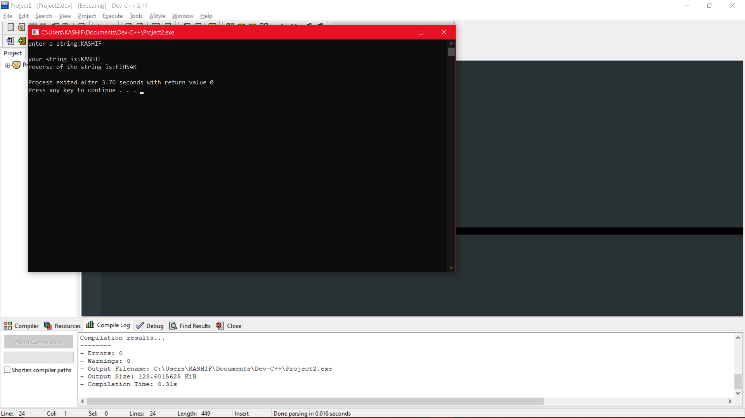

# (f) Whether the string is a palindrome.

**Algorithm:**

**1) START**

**2) SAVE THE STRING IN S**

**3) INITIALISE I=0,C=LENGTH,RUN A LOOP**

**TILL S[C]!=’\0’**

**4) STORE THE VALUE OF S[C] IN**

**S2[I],INCREMENT I**

**5) IF S2=S1**

**6) PRINT PALLINDROME**

**7) END**

***Flowchart:***

***Source Code:***

#include <stdio.h>

#include <stdlib.h>

/* run this program using the console pauser or add your own getch, system("pause") or input loop */

int main() {

char str[1000],rev[1000];

int i,j,k;

printf("enter a string:");

scanf("%s",str);

printf("\nyour string is:%s",str);

for(i=0;str[i]!='\0';i++)

{

k=i;

}

for(j=0;j<=i;j++)

{

rev[j]=str[k];

k--;

}

printf("\nreverse of the string is:%s",rev);

if(rev[j]==str)

printf("\n is a palidrome");

else if(rev[j]!=str)

printf("\n is not a palindrome");

return 0;

}

***Output:***

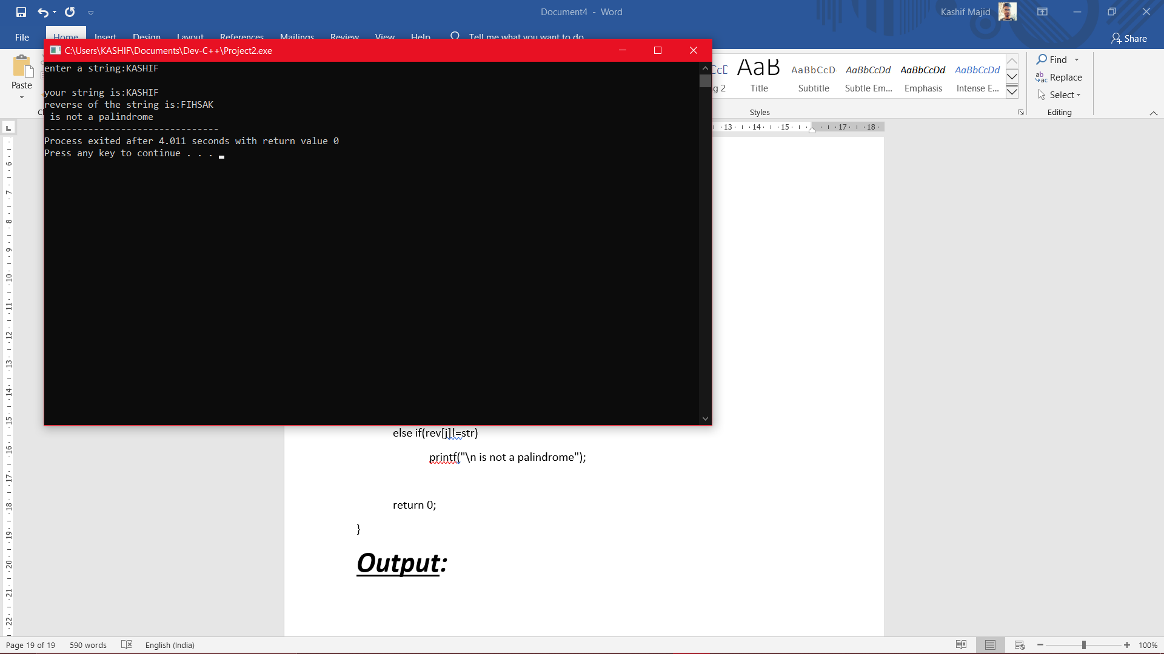

# (g) Compare the strings: equal/not equal

**Algorithm:**

**1) START**

**2) SAVE THE STRING IN S**

**3) SAVE THE SECOND STRING IN S2**

**4) RUN A LOOP TILL LENGTH OF THE STRING**

**5) IF S2[C]=S1[C]**

**6) THE STRINGS ARE EQUAL**

**7) END**

***Flowchart:***

***Source Code:***

#include <stdio.h>

#include <stdlib.h>

/* run this program using the console pauser or add your own getch, system("pause") or input loop */

int main() {

char a[1000],b[1000];

int i=0,j=0;

printf("enter a string:");

scanf("%s",a);

while(a[i] !='\0')

{

i++;

}

printf("\nlenght of the string is:%d",i);

printf("\nenter a string:");

scanf("%s",b);

while(b[j] !='\0')

{

j++;

}

printf("\nlenght of the string is:%d",j);

if(i==j)

printf("\nlength of both strings are same");

else

printf("\nlength of both strings are not same");

return 0;

}

***Output:***

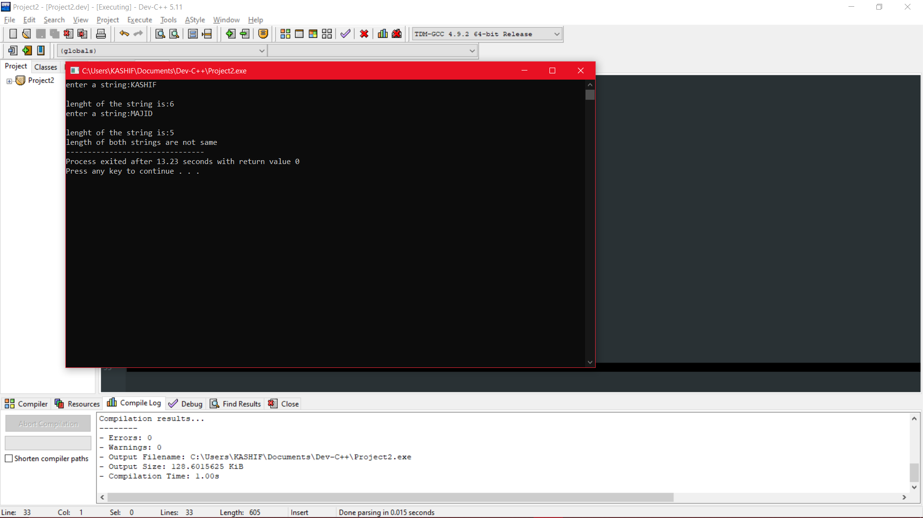

# (h) Find the longer string

**Algorithm:**

**1) START**

**2) SAVE THE STRING IN S**

**3) SAVE THE SECOND STRING IN S2**

**4) RUN A LOOP TILL LENGTH OF THE**

**STRING OF THE FIRST AND SECOND**

**STRING AND STORE VALUE IN LENGTH 1**

**AND LENGTH2**

**5) DISPLAY THE STRING WHICH HAS**

**GREATER LENGTH**

# 7) END

***Flowchart:***

***Source Code:***

#include <stdio.h>

#include <stdlib.h>

/* run this program using the console pauser or add your own getch, system("pause") or input loop */

int main() {

int i,j;

char a[100],b[100];

printf("enter a string:");

scanf("%s",a);

while(a[i] !='\0')

{

i++;

}

printf("\nlenght of the string is:%d",i);

printf("\nenter a string:");

scanf("%s",b);

while(b[j] !='\0')

{

j++;

}

printf("\nlenght of the string is:%d",j);

if(i>j)

printf("\nstring %s is greater than string %s",a,b);

else

printf("\nstring %s is greater than string %s",b,a);

return 0;

}

***Output:***

